Stakeholder Identification

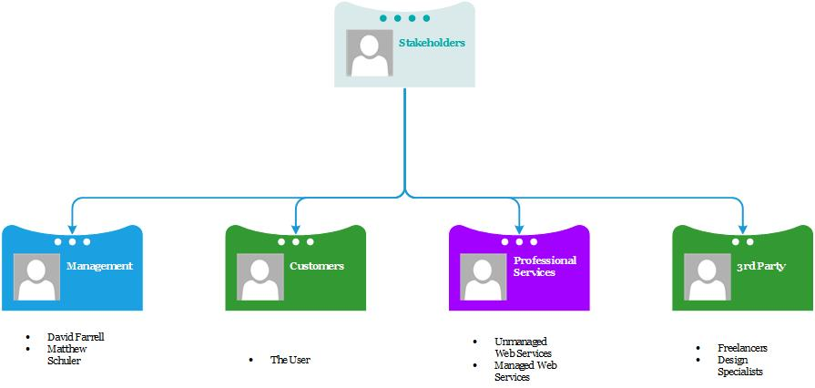

Stakeholders:

* Management
  + David & Matthew
* Customers
  + The User
* Professional Services
  + Unmanaged Web Services
  + Managed Web Services
* 3rd Party
  + The Freelancers